**THE HAUNTED STATES OF AMERICA**

The project’s goal is to develop a one-stop experience to search for haunted places in the United States.

The web site has 3 sections:

* **Home**

It is a content page including history of how the tradition of haunted places arrived and spread across the United States. The user is invited to explore further information related to the subject in the following sections: map and spooky data.

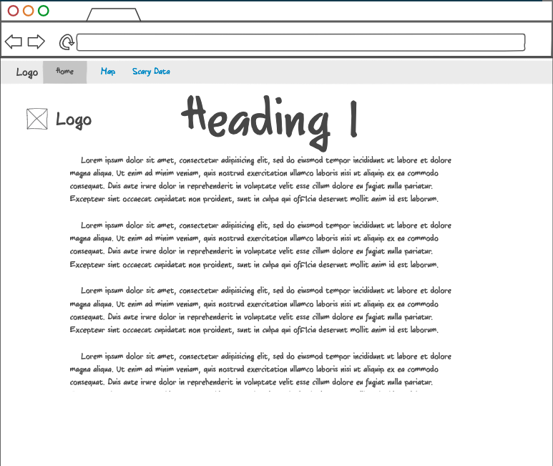

* **Map**

The project has a database with over 11,000 confirmed haunted places throughout the United States. The map is the best approach for the user’s experience. The map shows each haunted house with a marker while the user can easily visualize and select any of these for further information. When selecting a haunted place, a tooltip pops-up detailing the place’s name, state, city, and a brief description. To narrow down the search, a filter with the States is included as well as another filter with place’s type/theme (house, hospital, asylum, cemetery, etc.)

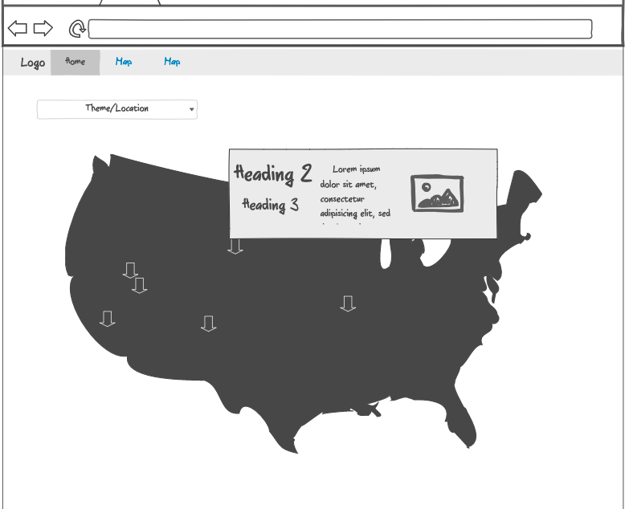

* **Spooky Data**

This view includes a dashboard with at least 3 visualizations that update based on the selected State:

* + *Top 10 Cities*: Horizontal bar graph with the top 10 cities having more haunted places. The “y-axis” has the city’s name and the “x-axis” the number of haunted places in each city.
  + *Word Cloud*: The world cloud shows the more frequent words included in the location for the haunted places in the selected State.

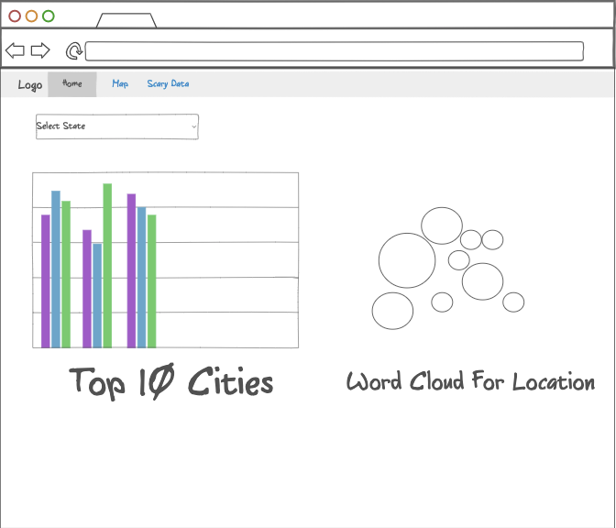

* **Data sets:**

**Source of data:** <https://data.world/timothyrenner/haunted-places>

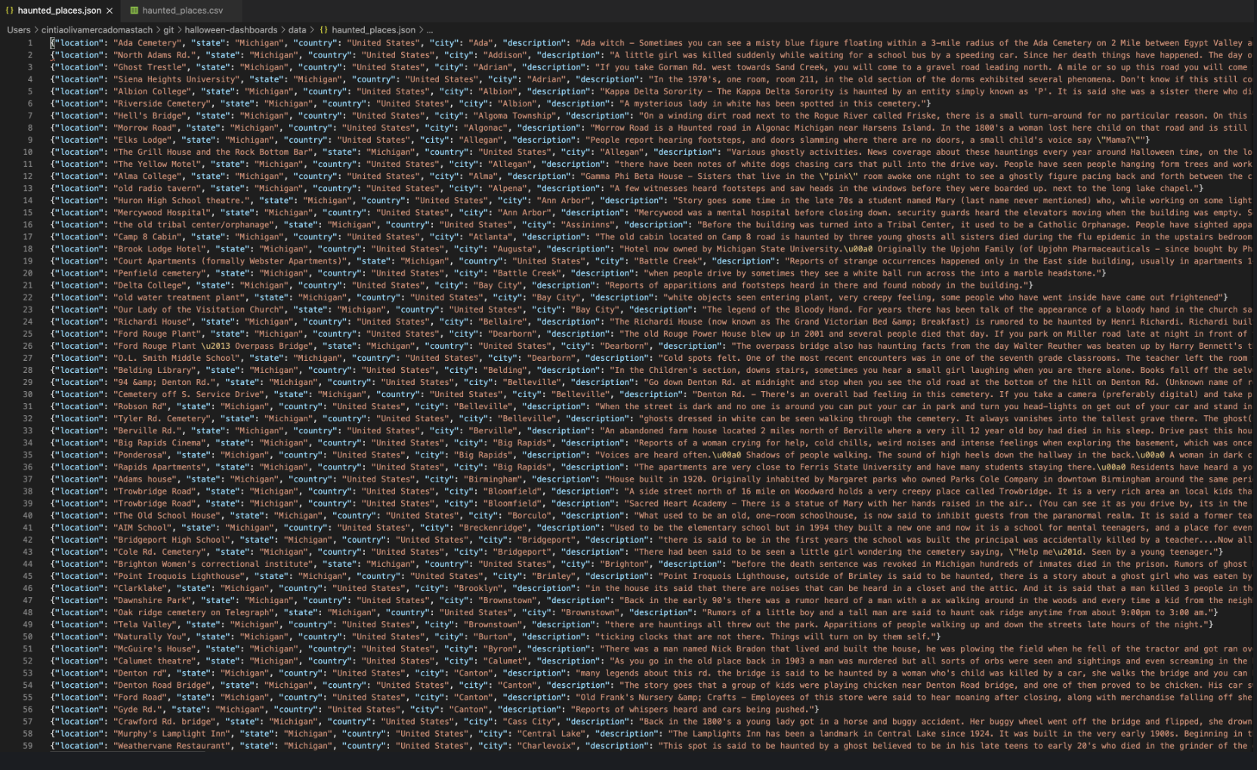

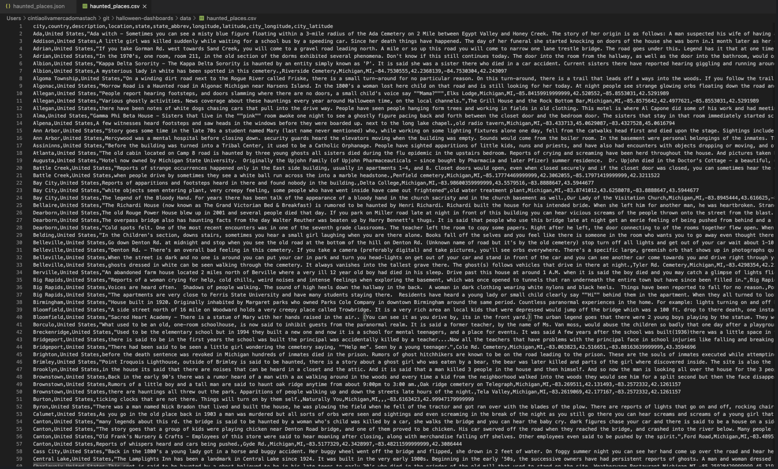

* **Inspiring visualizations:**

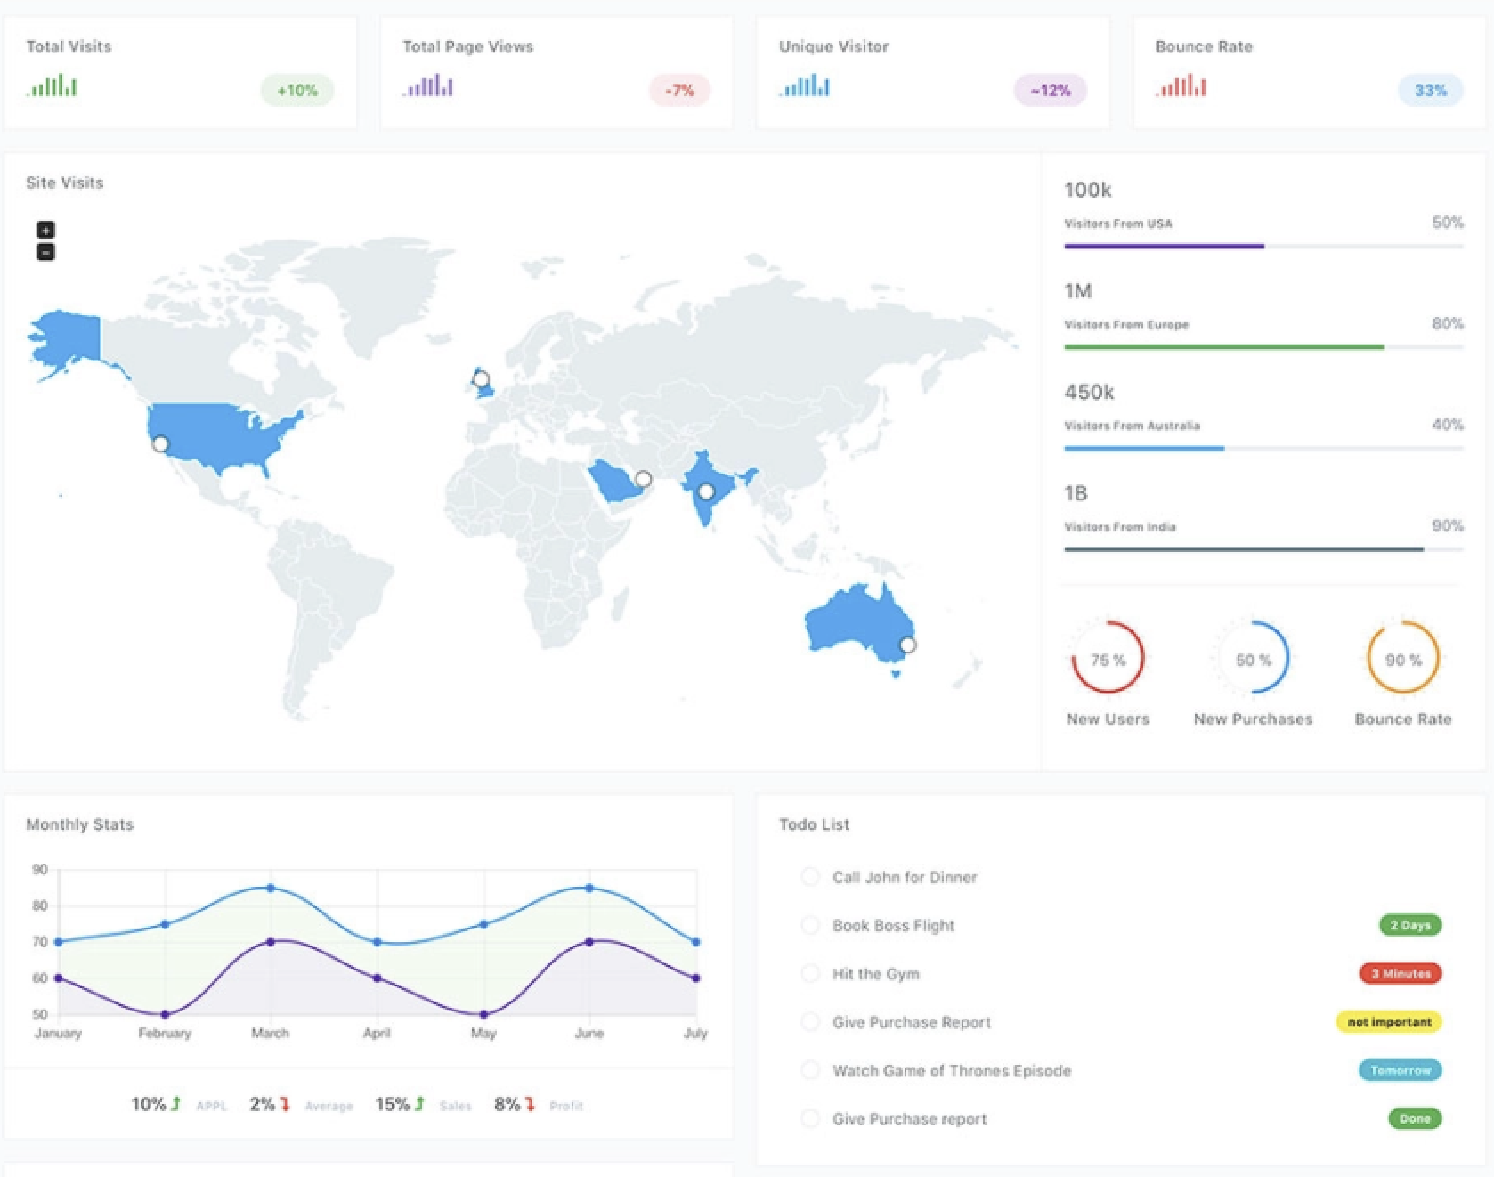

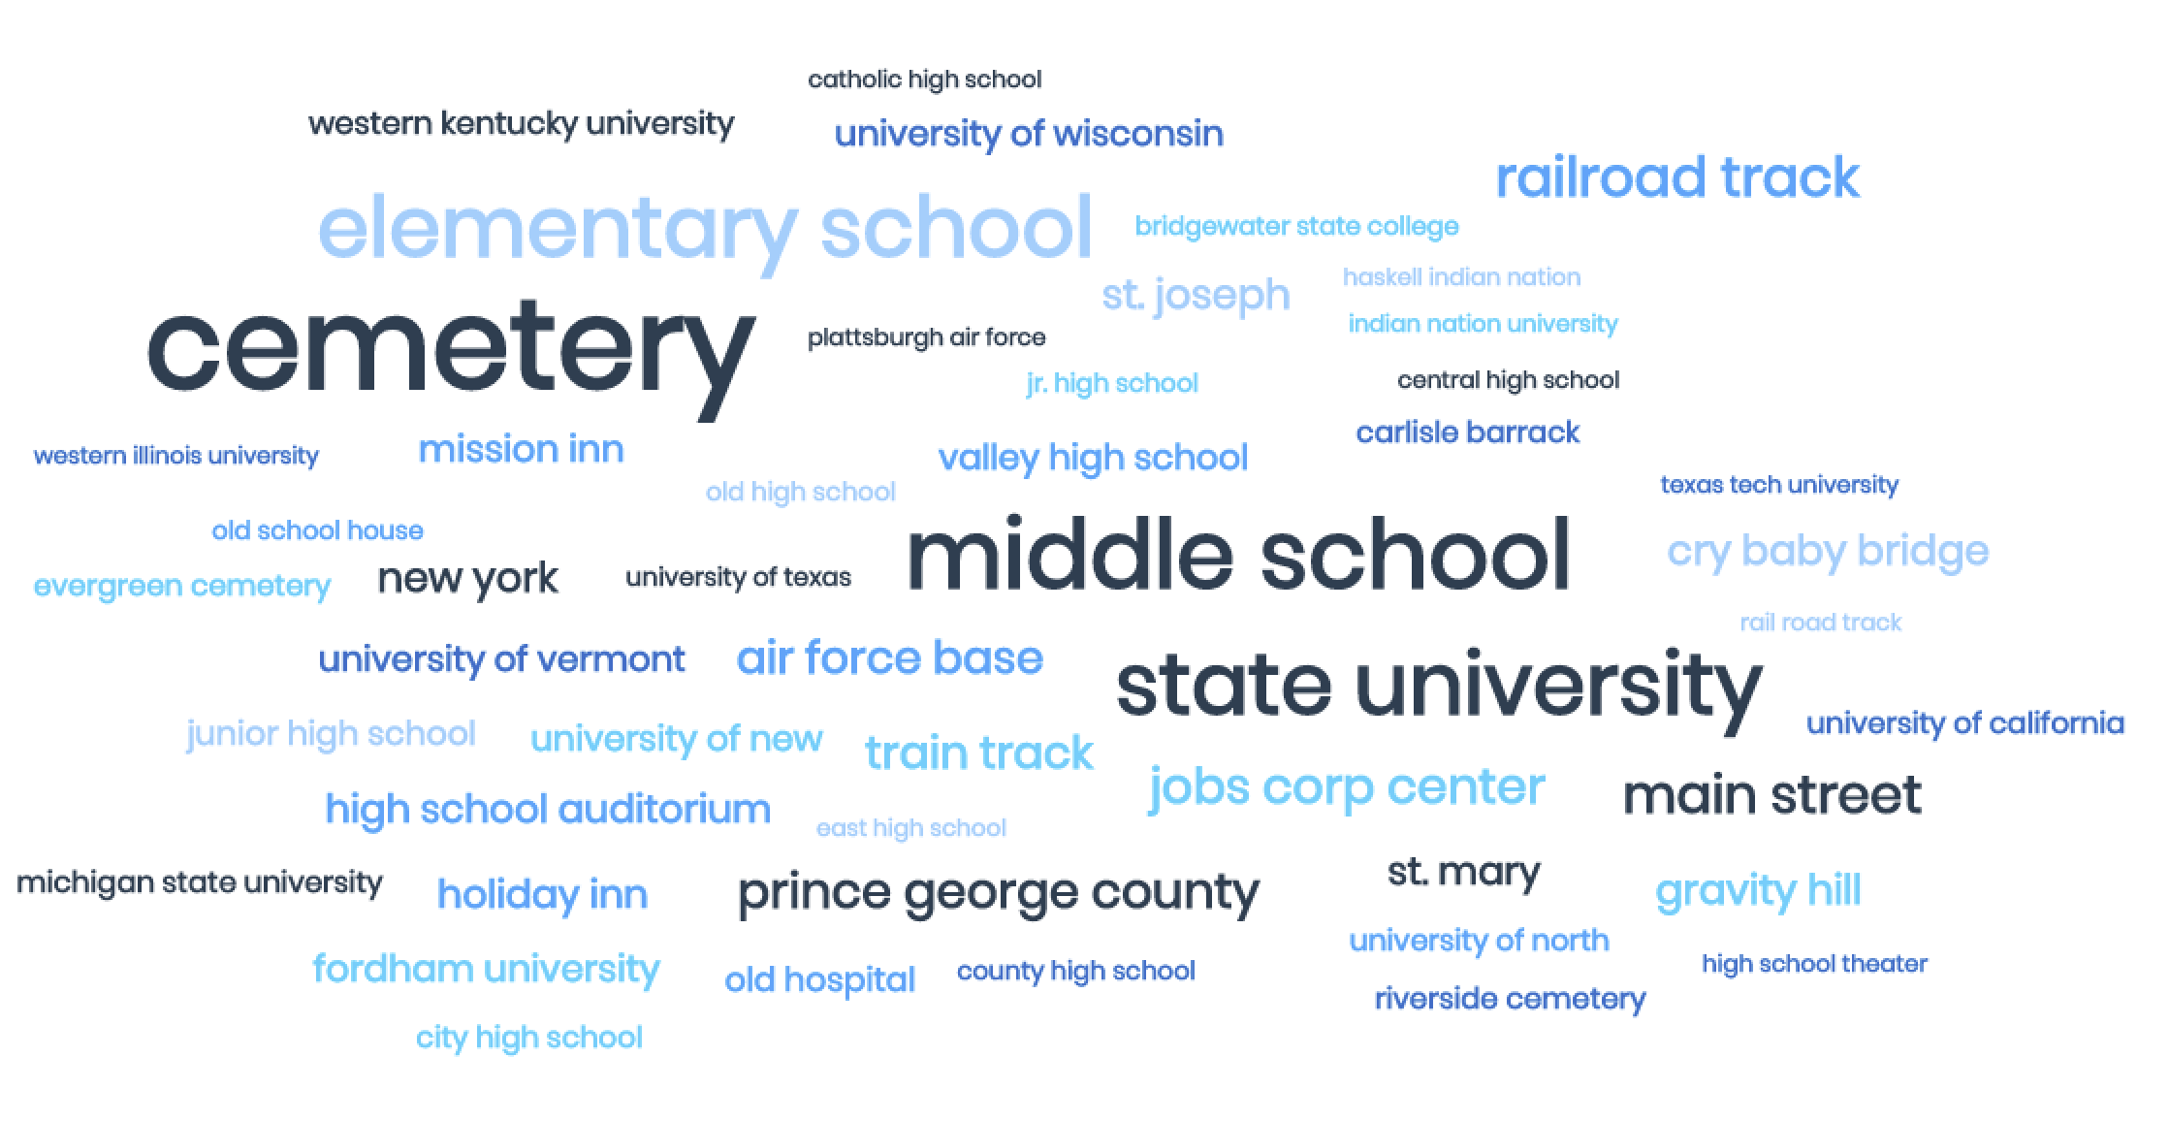

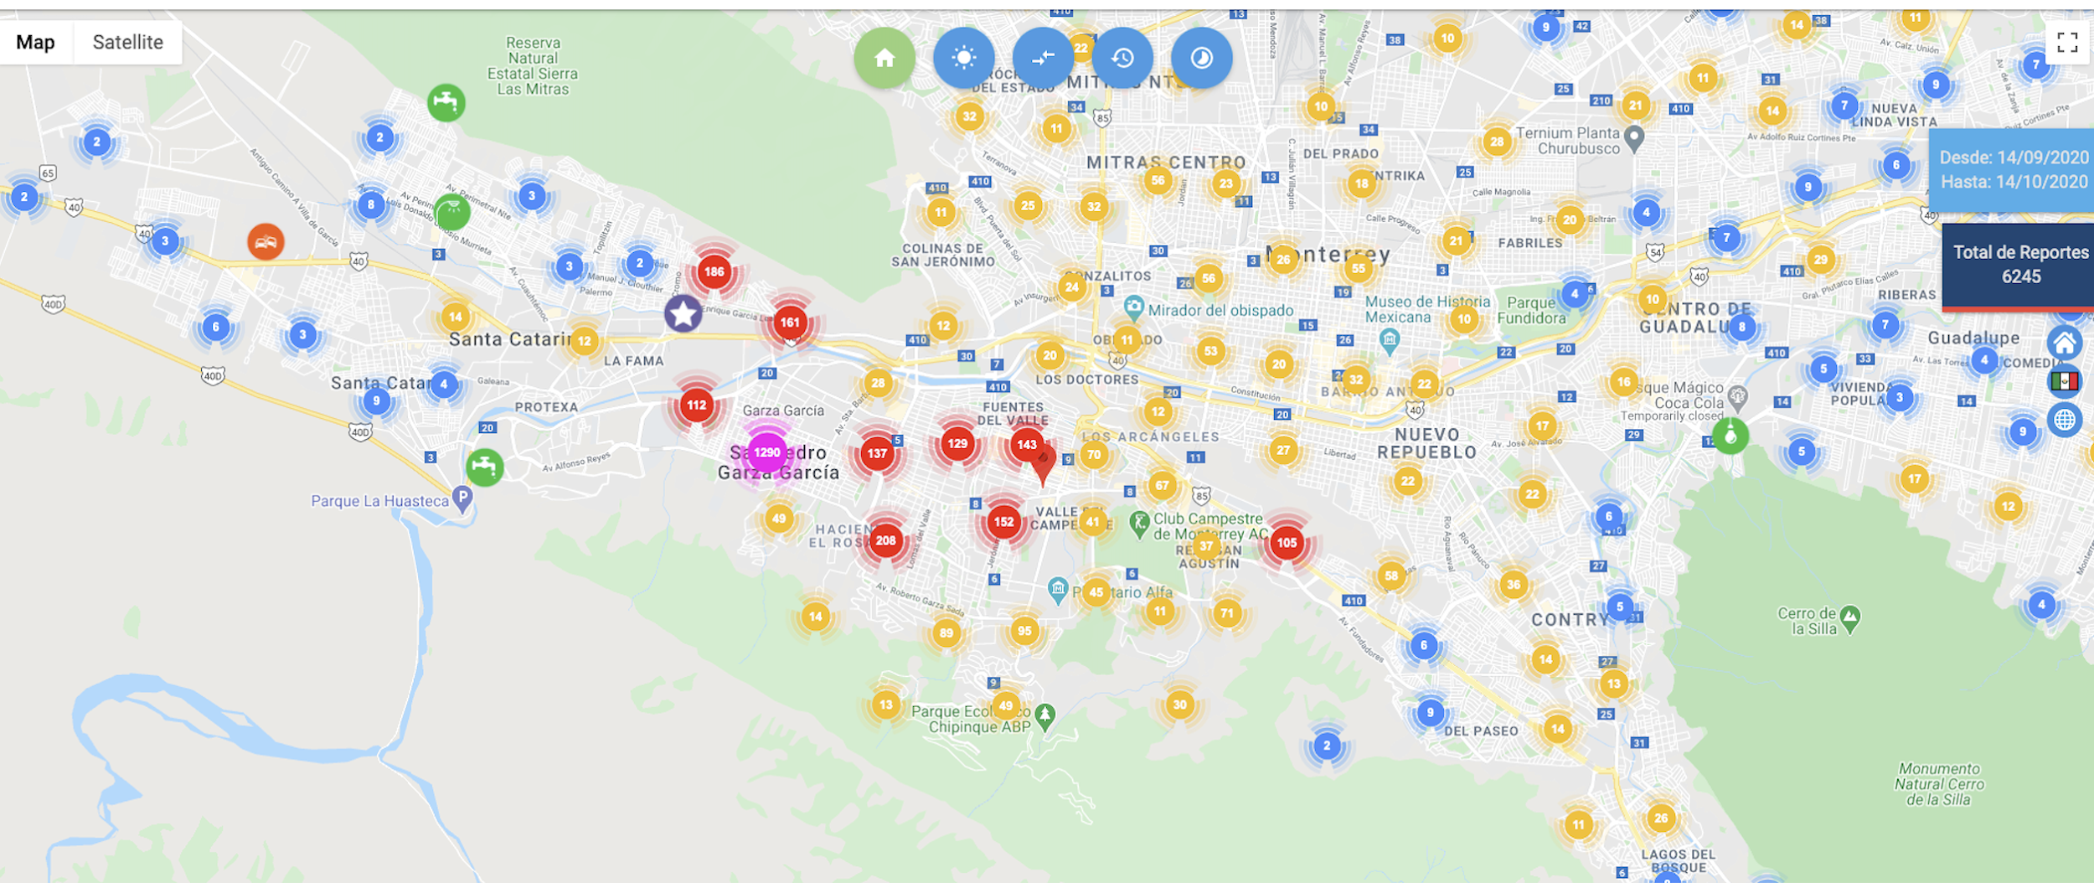

* **GitHub Repository:**

<https://github.com/mastachi-cin/halloween-dashboards.git>

**TEAM 2:**

* **Carlos Bugeda**
* **Luis Cavazos**
* **Eduardo Garza**
* **Cintia Mercado**